Java Quiz – Variables, Conditionals, Methods

1. Java variables are either are: _______________ OR ______________

2. Name 4 primitive variable types: ____________, ____________, ____________, ____________

3. What are the Java symbols for:

1. addition ____________
2. integer division ____________
3. is equal to ____________
4. AND ____________
5. is greater than ____________

4.

|  |  |  |  |  |  |  |  |  |  |
| --- | --- | --- | --- | --- | --- | --- | --- | --- | --- |
| a) | int x = 1; |  | b) | double x = 4; |  | c) | int x = 4; |  |  |
|  | x++; |  |  | x = Math.pow(x,2); |  |  | if (x==6) |  |  |
|  | x += 2; |  |  |  |  |  | x = 3; |  |  |
|  |  |  |  |  |  |  |  |  |  |
|  |  | x = |  |  | x = |  |  | x = |  |
|  |  |  |  |  |  |  |  |  |  |
| d) | double x = 14; | | e) | int x = 14; |  | f) | int x = 5; |  |  |
|  | x = x-- + 4; | |  | x = --x % 3; |  |  | x+=5; |  |  |
|  |  |  |  |  |  |  |  |  |  |
|  |  |  |  |  |  |  |  |  |  |
|  |  | x = |  |  | x = |  |  | x = |  |

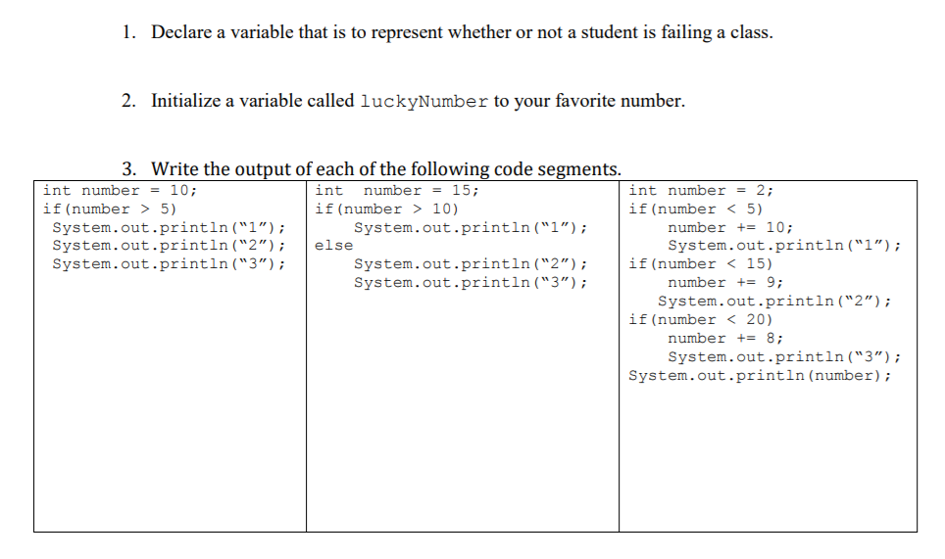

8. What is the output of the following?

boolean valA = true;

int valB = 32;

int valC = 4;

valA = !valA || valB % valC == 0;

if(valA){

valC--;

valB /= valC;

}

if(valB <= valC)

valC--;

else{

valB %= valC;

valA = !valA;

}

System.out.println("valA is " + valA);

System.out.println("valB is " + valB);

System.out.println("valC is " + valC);

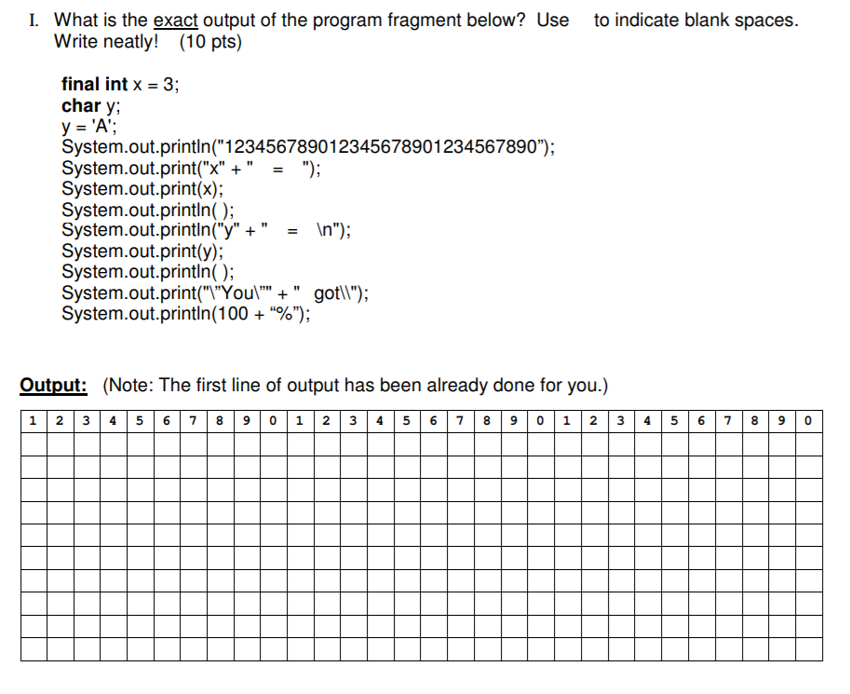

10. Write a method called eligibleVoter which takes in a parameter called age and returns true/false based on if they are eligible to vote.

11. public static int north( int num1, int num2) {

int temp = num1;

num1 = num2;

num2 = temp;

System.out.print( num1+ “ “ + num2 + “ ”);

return (3 * (num1 - num2));

}

How do you call this method? What will the method return?

* Assume the parameters are num1 = 2 and num2 = 3*